**Technical Specification**

**BOM, EO**

* Domain: CDM BOM
* Author: jaehee Lee
* Created: 2017-03-03
* Modified: 2017-03-03

# Change History

|  |  |  |  |
| --- | --- | --- | --- |
| Date | Revision | Reviser | Revised contents |
| 2017-03-03 | 0 | JH LEE |  |
|  |  |  |  |
|  |  |  |  |
|  |  |  |  |
|  |  |  |  |

**Table of Contents**

1 Change History 2

2 Introduction 4

2.1 Purpose 4

3 Overview 5

3.1 Functionality Provide 5

3.2 Reference Functional Specification Document 5

3.3 Function List 5

3.4 Roles/Access 5

4 Data Model 5

4.1 Type & Relationship Diagram 5

4.2 Instance Model (Optional) 6

4.3 Type & Relationship Trigger 6

5 Policy 6

5.1 Policy State 6

5.2 Policy Trigger 7

6 기타 Trigger 7

7 UI Components 7

7.1 BOM-FSP-00360 BOM 편집 – 7

7.1.1 UI Design 7

7.1.2 Tables 8

7.1.3 Web Forms 8

7.1.4 Commands 8

7.1.5 Menus 8

7.1.6 Channels 8

7.1.7 Portals 8

7.2 BOM-FSP-00370 BOM 편집 – 9

7.2.1 UI Design 9

7.2.2 Tables 9

7.2.3 Web Forms 9

7.2.4 Commands 9

7.2.5 Menus 9

7.2.6 Channels 10

7.2.7 Portals 10

7.3 BOM-FSP-00380 BOM 편집 – 10

7.3.1 UI Design 10

7.3.2 Tables 10

7.3.3 Web Forms 10

7.3.4 Commands 10

7.3.5 Menus 10

7.3.6 Channels 11

7.3.7 Portals 11

7.4 BOM-FSP-00390 BOM 편집 – 11

7.4.1 UI Design 11

7.4.2 Tables 12

7.4.3 Web Forms 12

7.4.4 Commands 12

7.4.5 Menus 12

7.4.6 Channels 12

7.4.7 Portals 12

7.5 BOM-FSP-00400 BOM 편집 – 13

7.5.1 UI Design 13

7.5.2 Tables 13

7.5.3 Web Forms 13

7.5.4 Commands 13

7.5.5 Menus 13

7.5.6 Channels 13

7.5.7 Portals 14

8 Programs 14

8.1 BOM-FSP-00360 BOM 편집 14

8.1.1 Function Flow / Program Logic 14

8.1.2 JSP 14

8.1.3 JPO 14

8.1.4 Bean 14

8.1.5 CAA 14

8.1.6 INQUERY 14

8.2 BOM-FSP-00370 BOM 편집 15

8.2.1 Function Flow / Program Logic 15

8.2.2 JSP 15

8.2.3 JPO 15

8.2.4 Bean 15

8.2.5 CAA 15

8.2.6 INQUERY 15

8.3 BOM-FSP-00380 BOM 편집 16

8.3.1 Function Flow / Program Logic 16

8.3.2 JSP 16

8.3.3 JPO 16

8.3.4 Bean 16

8.3.5 CAA 16

8.3.6 INQUERY 16

8.4 BOM-FSP-00390 BOM 편집 – 16

8.4.1 Function Flow / Program Logic 16

8.4.2 JSP 16

8.4.3 JPO 16

8.4.4 Bean 16

8.4.5 CAA 16

8.4.6 INQUERY 16

8.5 BOM-FSP-00400 BOM 편집 – 17

8.5.1 Function Flow / Program Logic 17

8.5.2 JSP 17

8.5.3 JPO 17

8.5.4 Bean 17

8.5.5 CAA 17

8.5.6 INQUERY 17

9 Configurable Properties (Server Side) 17

10 Design Solution & Limitation 17

# Introduction

## Purpose

The purpose of this document is to define the detailed design for customization. The contents to be described in this document are as below.

• Schema

• Data model

• Object model

• UI components

• Feature logic flow

The technical specification document:

• Generates a comprehensive description of the operational scope,

• Defines both functional and technical constraints, e.g. functionalities, user interface design.

# Overview

## Functionality Provide

☞ 이 문서에서 제공하는 기능에 대한 설명을 간단히 기술한다.☜

국제화/지역화를 지원하기 위한 Common Code 오브젝트에 관련된 모든 기능을 이 문서에서 제공한다.

## Reference Functional Specification Document

☞ 관련된 Functional Specification의 파일명을 기술한다. 만약 없으면 “n/a”로 표시한다. ☜

* n/a

## Function List

|  |  |  |
| --- | --- | --- |
| Func. ID | Func. Name | Description |
|  |  | n/a |
|  |  | n/a |
|  |  | n/a |
|  |  | n/a |
|  |  | n/a |

## Roles/Access

☞ 이 문서에서 제공하는 기능을 사용하기 위해 필요한 role (system에 정의된 role) 및 Access level(Ex,생성/수정/삭제 등)을 기술한다. 만약 기술할 내용이 없는 경우 테이블 컬럼에 “n/a”로 표시한다. ☜

|  |  |  |  |
| --- | --- | --- | --- |
| Role Name | Description | Access Level | Custom/OOTB |
| n/a | n/a | n/a | n/a |

# Data Model

## Type & Relationship Diagram

☞ 만약 기술할 데이터 모델이 없을 경우는 n/a로 표시하고, 다른 문서에 기술되어 있는 것을 참조할 경우 참조할 문서명을 기술한다. 신규 Type/Relationship이 OOTB Type 또는 Relationship을 상속 받았을 경우 상속 관계도 함께 표시한다.☜

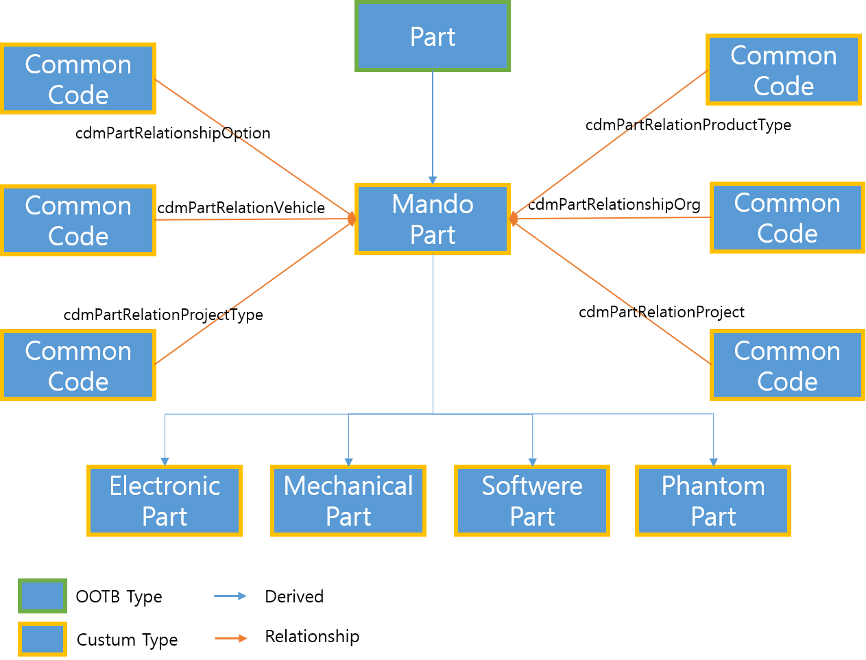

## Instance Model (Optional)

☞ 실제 데이터가 생성되었을 때의 데이터 구조를 기술한다. 만약 기술할 Instance모델이 없을 경우는 ”n/a”로 표시하고, 다른 문서에 기술되어 있는 것을 참조할 경우 참조할 문서명을 기술한다.☜

* + - n/a

## Type & Relationship Trigger

☞ Type 또는 Relationship에 정의되는 Trigger object를 기술한다. 만약 정의된 trigger가 없으면 “n/a”로 표시한다.☜

|  |  |  |  |
| --- | --- | --- | --- |
| Trigger Type | Trigger Object Name | Trigger Object Revision | Description |
| n/a | n/a | n/a | n/a |

# Policy

## Policy State

☞ 사용하는 Policy와 Policy에 정의되는 상태를 도시적으로 표시한다. 만약 policy정의가 필요 없는 기능이면 “n/a”로 표시한다.☜

* cdmPartPolicy

## Policy Trigger

☞ Policy에 정의되는 Trigger object를 기술한다. 만약 정의된 trigger가 없으면 “n/a”로 표시한다. 아래 테이블의 # 컬럼은 5.1절에 표현된 Lifecycle상의 signature 또는 branch 중 trigger가 실행되는 곳의 Index No를 입력한다.☜

|  |  |  |  |
| --- | --- | --- | --- |
| # | Trigger Object Name | Trigger Object Revision | Description |
| n/a | n/a | n/a | n/a |

# 기타 Trigger

☞ Attribute에 정의되는 trigger가 있을 경우, 기술하고 없으면 n/a로 표시한다. ☜

|  |  |  |  |
| --- | --- | --- | --- |
| Trigger Type | Trigger Object Name | Trigger Object Revision | Description |
| n/a | n/a | n/a | n/a |

# UI Components

☞ 기능 구현을 위해 사용된 UI component를 Func. ID별로 기술한다. 사용되지 않은 UI component가 있으면 해당 테이블 컬럼에 n/a로 표시하고, 만약 사용된 UI component가 전혀 없는 경우는 FUNC. ID 를 기술하고 n/a로만 표시한다. UI Design은 FSP에 정의된 것을 복사하여 사용하도록 한다. 1개의 FUNC ID에 동일한 UI Components가 1개 이상이 사용될 때 구분을 위해 UI Design에 INDEX #를 부여하고 UI Component 리스트에 INDEX #를 기술한다.☜

## BOM-FSP-00100 BOM 편집 – Part 생성

### UI Design

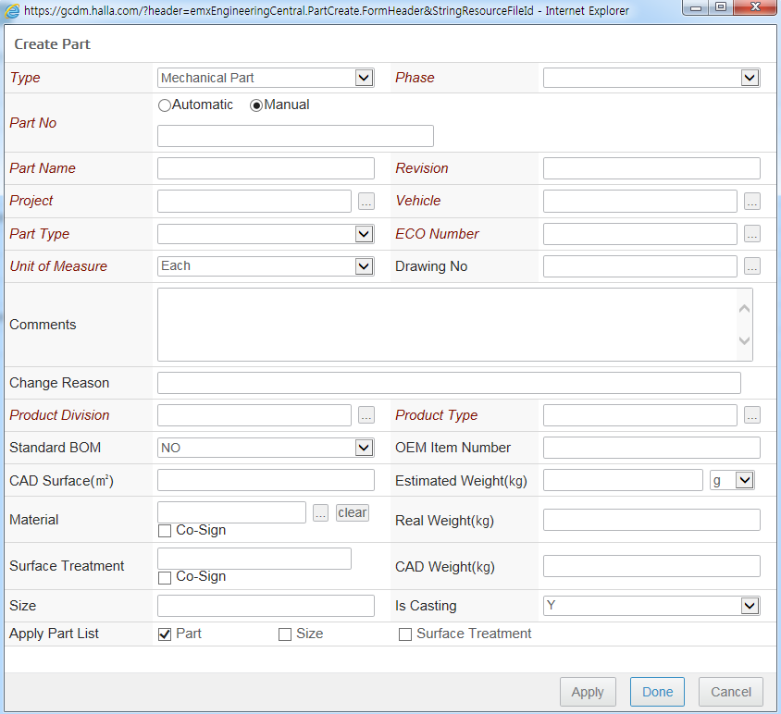

### Tables

|  |  |  |  |
| --- | --- | --- | --- |
| **#** | **Name** | **Description** | **Columns** |
| n/a | n/a | n/a | n/a |

### Web Forms

|  |  |  |  |
| --- | --- | --- | --- |
| **#** | **Name** | **Description** | **Fields** |
| n/a | n/a | n/a | n/a |

### Commands

|  |  |  |
| --- | --- | --- |
| **#** | **Name** | **Description** |
| n/a |  | n/a |

### Menus

|  |  |  |  |
| --- | --- | --- | --- |
| **#** | **Name** | **Description** | **Components** |
| 1 |  |  |  |

### Channels

|  |  |  |  |
| --- | --- | --- | --- |
| **#** | **Name** | **Description** | **Components** |
| n/a | n/a | n/a | n/a |

### Portals

|  |  |  |  |
| --- | --- | --- | --- |
| **#** | **Name** | **Description** | **Components** |
| n/a | n/a | n/a | n/a |

## BOM-FSP-00110 BOM 편집 – Part 생성 (PhantomPart)

### UI Design

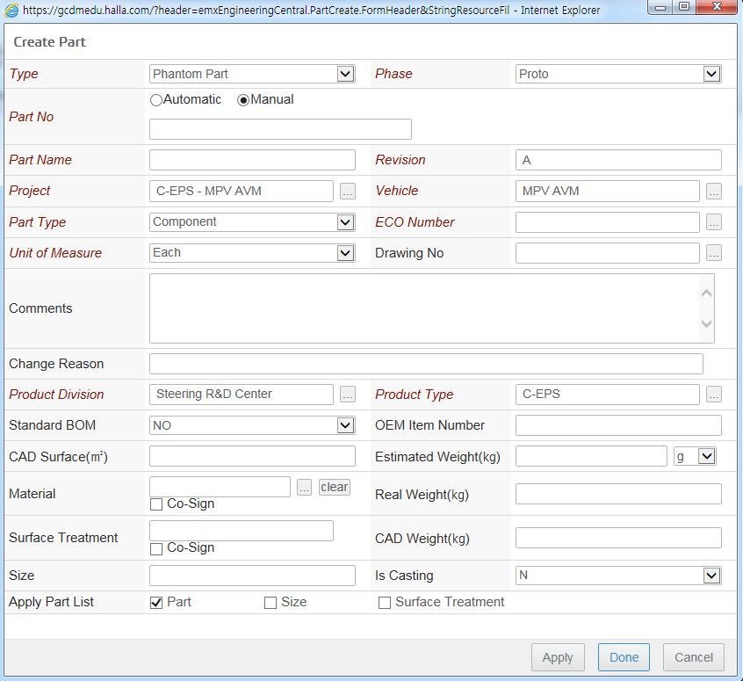

### Tables

|  |  |  |  |
| --- | --- | --- | --- |
| **#** | **Name** | **Description** | **Columns** |
| 1 |  |  |  |

### Web Forms

|  |  |  |  |
| --- | --- | --- | --- |
| **#** | **Name** | **Description** | **Fields** |
| 1 |  |  |  |

### Commands

|  |  |  |
| --- | --- | --- |
| **#** | **Name** | **Description** |
| 1 |  |  |
| 2 |  |  |

### Menus

|  |  |  |  |
| --- | --- | --- | --- |
| **#** | **Name** | **Description** | **Components** |
| 1 |  |  |  |
| 2 |  |  |  |
| 3 |  |  |  |

### Channels

|  |  |  |  |
| --- | --- | --- | --- |
| **#** | **Name** | **Description** | **Components** |
| n/a | n/a | n/a | n/a |

### Portals

|  |  |  |  |
| --- | --- | --- | --- |
| **#** | **Name** | **Description** | **Components** |
| n/a | n/a | n/a | n/a |

## BOM-FSP-00120 BOM 편집 – Part생성 (Mechanical Part)

### UI Design

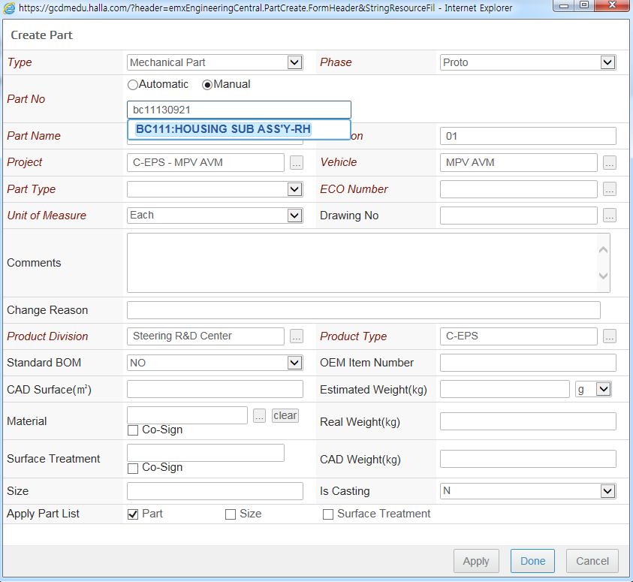

### Tables

|  |  |  |  |
| --- | --- | --- | --- |
| **#** | **Name** | **Description** | **Columns** |
| n/a | n/a | n/a | n/a |

### Web Forms

|  |  |  |  |
| --- | --- | --- | --- |
| **#** | **Name** | **Description** | **Fields** |
| 1 | type_cdmCommonCode | Common Code Form | n/a |

### Commands

|  |  |  |
| --- | --- | --- |
| **#** | **Name** | **Description** |
| n/a | n/a | n/a |

### Menus

|  |  |  |  |
| --- | --- | --- | --- |
| **#** | **Name** | **Description** | **Components** |
| 1 | type_cdmCommonCode | Common Code Tree Menu | **command** cdmCommonCodeTreeTableCommand  cdmCommonCodeWhereUsedTableCommand  AEFHistory  AEFLifecycleBasic |

### Channels

|  |  |  |  |
| --- | --- | --- | --- |
| **#** | **Name** | **Description** | **Components** |
| n/a | n/a | n/a | n/a |

### Portals

|  |  |  |  |
| --- | --- | --- | --- |
| **#** | **Name** | **Description** | **Components** |
| n/a | n/a | n/a | n/a |

## BOM-FSP-00130 BOM 편집 – Part 생성 (EO등록)

### UI Design

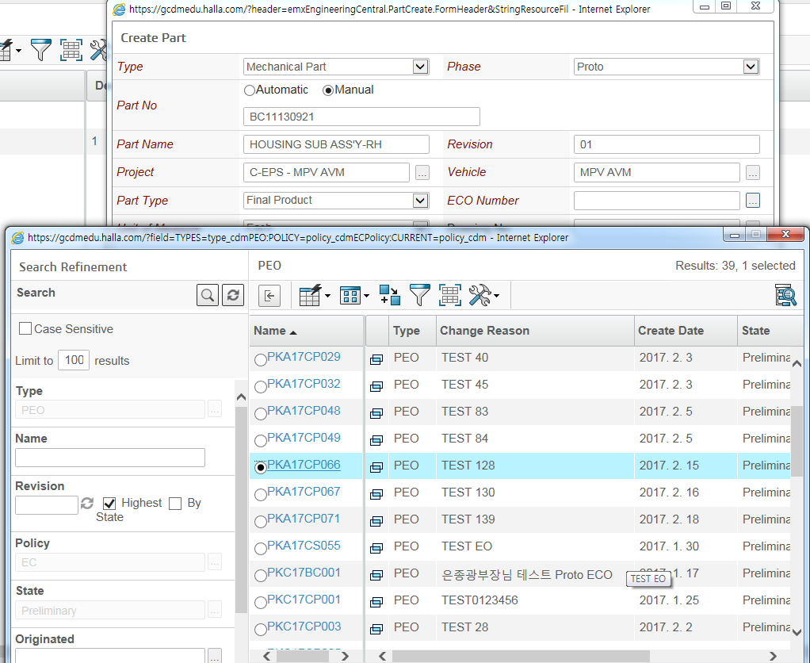

### Tables

|  |  |  |  |
| --- | --- | --- | --- |
| **#** | **Name** | **Description** | **Columns** |
| n/a | n/a | n/a | n/a |

### Web Forms

|  |  |  |  |
| --- | --- | --- | --- |
| **#** | **Name** | **Description** | **Fields** |
| n/a | n/a | n/a | n/a |

### Commands

|  |  |  |
| --- | --- | --- |
| **#** | **Name** | **Description** |
| 1 | cdmENCCreatePartActions | n/a |

### Menus

|  |  |  |  |
| --- | --- | --- | --- |
| **#** | **Name** | **Description** | **Components** |
| 1 2 3 | Actions  ENCActions ENCPartAction | n/a | n/a |

### Channels

|  |  |  |  |
| --- | --- | --- | --- |
| **#** | **Name** | **Description** | **Components** |
| n/a | n/a | n/a | n/a |

### Portals

|  |  |  |  |
| --- | --- | --- | --- |
| **#** | **Name** | **Description** | **Components** |
| n/a | n/a | n/a | n/a |

## BOM 편집 – Part 생성 (Drawing등록)

### UI Design

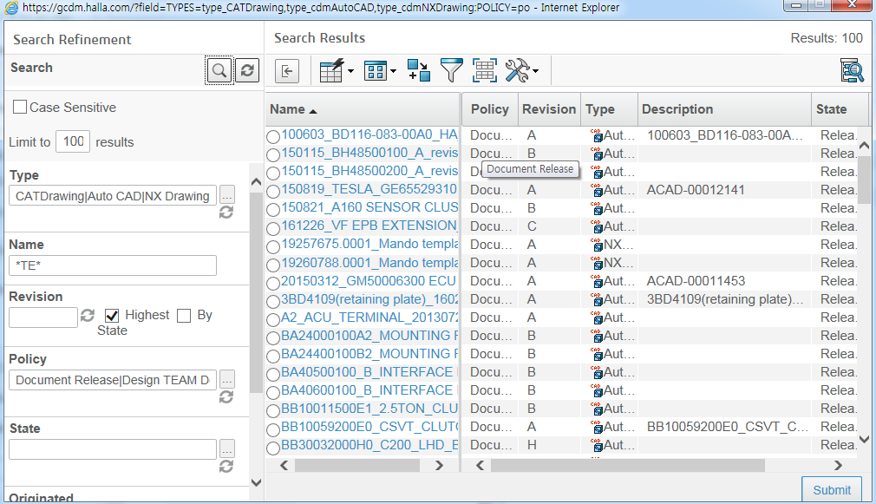

### Tables

|  |  |  |  |
| --- | --- | --- | --- |
| **#** | **Name** | **Description** | **Columns** |
| 1 |  |  |  |

### Web Forms

|  |  |  |  |
| --- | --- | --- | --- |
| **#** | **Name** | **Description** | **Fields** |
| n/a | n/a | n/a | n/a |

### Commands

|  |  |  |
| --- | --- | --- |
| **#** | **Name** | **Description** |
| 1 |  |  |

### Menus

|  |  |  |  |
| --- | --- | --- | --- |
| **#** | **Name** | **Description** | **Components** |
| 1 |  |  |  |
| 2 |  |  |  |

### Channels

|  |  |  |  |
| --- | --- | --- | --- |
| **#** | **Name** | **Description** | **Components** |
| n/a | n/a | n/a | n/a |

### Portals

|  |  |  |  |
| --- | --- | --- | --- |
| **#** | **Name** | **Description** | **Components** |
| n/a | n/a | n/a | n/a |

## Programs BOM 편집 – Part 생성 (Drawing등록)

### UI Design

### Tables

|  |  |  |  |
| --- | --- | --- | --- |
| **#** | **Name** | **Description** | **Columns** |
| 1 |  |  |  |

### Web Forms

|  |  |  |  |
| --- | --- | --- | --- |
| **#** | **Name** | **Description** | **Fields** |
| n/a | n/a | n/a | n/a |

### Commands

|  |  |  |
| --- | --- | --- |
| **#** | **Name** | **Description** |
| 1 |  |  |

### Menus

|  |  |  |  |
| --- | --- | --- | --- |
| **#** | **Name** | **Description** | **Components** |
| 1 |  |  |  |
| 2 |  |  |  |

### Channels

|  |  |  |  |
| --- | --- | --- | --- |
| **#** | **Name** | **Description** | **Components** |
| n/a | n/a | n/a | n/a |

### Portals

|  |  |  |  |
| --- | --- | --- | --- |
| **#** | **Name** | **Description** | **Components** |
| n/a | n/a | n/a | n/a |

## BOM 편집 – Part 생성 (Drawing등록) BOM 편집 – Part 생성 (Drawing등록)

### UI Design

### Tables

|  |  |  |  |
| --- | --- | --- | --- |
| **#** | **Name** | **Description** | **Columns** |
| 1 |  |  |  |

### Web Forms

|  |  |  |  |
| --- | --- | --- | --- |
| **#** | **Name** | **Description** | **Fields** |
| n/a | n/a | n/a | n/a |

### Commands

|  |  |  |
| --- | --- | --- |
| **#** | **Name** | **Description** |
| 1 |  |  |

### Menus

|  |  |  |  |
| --- | --- | --- | --- |
| **#** | **Name** | **Description** | **Components** |
| 1 |  |  |  |
| 2 |  |  |  |

### Channels

|  |  |  |  |
| --- | --- | --- | --- |
| **#** | **Name** | **Description** | **Components** |
| n/a | n/a | n/a | n/a |

### Portals

|  |  |  |  |
| --- | --- | --- | --- |
| **#** | **Name** | **Description** | **Components** |
| n/a | n/a | n/a | n/a |

## BOM 편집 – Part 생성 (Drawing등록)

### UI Design

### Tables

|  |  |  |  |
| --- | --- | --- | --- |
| **#** | **Name** | **Description** | **Columns** |
| 1 |  |  |  |

### Web Forms

|  |  |  |  |
| --- | --- | --- | --- |
| **#** | **Name** | **Description** | **Fields** |
| n/a | n/a | n/a | n/a |

### Commands

|  |  |  |
| --- | --- | --- |
| **#** | **Name** | **Description** |
| 1 |  |  |

### Menus

|  |  |  |  |
| --- | --- | --- | --- |
| **#** | **Name** | **Description** | **Components** |
| 1 |  |  |  |
| 2 |  |  |  |

### Channels

|  |  |  |  |
| --- | --- | --- | --- |
| **#** | **Name** | **Description** | **Components** |
| n/a | n/a | n/a | n/a |

### Portals

|  |  |  |  |
| --- | --- | --- | --- |
| **#** | **Name** | **Description** | **Components** |
| n/a | n/a | n/a | n/a |

## BOM 편집 – Part 생성 (Drawing등록)

### UI Design

### Tables

|  |  |  |  |
| --- | --- | --- | --- |
| **#** | **Name** | **Description** | **Columns** |
| 1 |  |  |  |

### Web Forms

|  |  |  |  |
| --- | --- | --- | --- |
| **#** | **Name** | **Description** | **Fields** |
| n/a | n/a | n/a | n/a |

### Commands

|  |  |  |
| --- | --- | --- |
| **#** | **Name** | **Description** |
| 1 |  |  |

### Menus

|  |  |  |  |
| --- | --- | --- | --- |
| **#** | **Name** | **Description** | **Components** |
| 1 |  |  |  |
| 2 |  |  |  |

### Channels

|  |  |  |  |
| --- | --- | --- | --- |
| **#** | **Name** | **Description** | **Components** |
| n/a | n/a | n/a | n/a |

### Portals

|  |  |  |  |
| --- | --- | --- | --- |
| **#** | **Name** | **Description** | **Components** |
| n/a | n/a | n/a | n/a |

## BOM 편집 – Part 생성 (Drawing등록)

### UI Design

### Tables

|  |  |  |  |
| --- | --- | --- | --- |
| **#** | **Name** | **Description** | **Columns** |
| 1 |  |  |  |

### Web Forms

|  |  |  |  |
| --- | --- | --- | --- |
| **#** | **Name** | **Description** | **Fields** |
| n/a | n/a | n/a | n/a |

### Commands

|  |  |  |
| --- | --- | --- |
| **#** | **Name** | **Description** |
| 1 |  |  |

### Menus

|  |  |  |  |
| --- | --- | --- | --- |
| **#** | **Name** | **Description** | **Components** |
| 1 |  |  |  |
| 2 |  |  |  |

### Channels

|  |  |  |  |
| --- | --- | --- | --- |
| **#** | **Name** | **Description** | **Components** |
| n/a | n/a | n/a | n/a |

### Portals

|  |  |  |  |
| --- | --- | --- | --- |
| **#** | **Name** | **Description** | **Components** |
| n/a | n/a | n/a | n/a |

## BOM 편집 – Part 생성 (Drawing등록)

### UI Design

### Tables

|  |  |  |  |
| --- | --- | --- | --- |
| **#** | **Name** | **Description** | **Columns** |
| 1 |  |  |  |

### Web Forms

|  |  |  |  |
| --- | --- | --- | --- |
| **#** | **Name** | **Description** | **Fields** |
| n/a | n/a | n/a | n/a |

### Commands

|  |  |  |
| --- | --- | --- |
| **#** | **Name** | **Description** |
| 1 |  |  |

### Menus

|  |  |  |  |
| --- | --- | --- | --- |
| **#** | **Name** | **Description** | **Components** |
| 1 |  |  |  |
| 2 |  |  |  |

### Channels

|  |  |  |  |
| --- | --- | --- | --- |
| **#** | **Name** | **Description** | **Components** |
| n/a | n/a | n/a | n/a |

### Portals

|  |  |  |  |
| --- | --- | --- | --- |
| **#** | **Name** | **Description** | **Components** |
| n/a | n/a | n/a | n/a |

## BOM 편집 – Part 생성 (Drawing등록)

### UI Design

### Tables

|  |  |  |  |
| --- | --- | --- | --- |
| **#** | **Name** | **Description** | **Columns** |
| 1 |  |  |  |

### Web Forms

|  |  |  |  |
| --- | --- | --- | --- |
| **#** | **Name** | **Description** | **Fields** |
| n/a | n/a | n/a | n/a |

### Commands

|  |  |  |
| --- | --- | --- |
| **#** | **Name** | **Description** |
| 1 |  |  |

### Menus

|  |  |  |  |
| --- | --- | --- | --- |
| **#** | **Name** | **Description** | **Components** |
| 1 |  |  |  |
| 2 |  |  |  |

### Channels

|  |  |  |  |
| --- | --- | --- | --- |
| **#** | **Name** | **Description** | **Components** |
| n/a | n/a | n/a | n/a |

### Portals

|  |  |  |  |
| --- | --- | --- | --- |
| **#** | **Name** | **Description** | **Components** |
| n/a | n/a | n/a | n/a |

## BOM 편집 – Part 생성 (Drawing등록)

### UI Design

### Tables

|  |  |  |  |
| --- | --- | --- | --- |
| **#** | **Name** | **Description** | **Columns** |
| 1 |  |  |  |

### Web Forms

|  |  |  |  |
| --- | --- | --- | --- |
| **#** | **Name** | **Description** | **Fields** |
| n/a | n/a | n/a | n/a |

### Commands

|  |  |  |
| --- | --- | --- |
| **#** | **Name** | **Description** |
| 1 |  |  |

### Menus

|  |  |  |  |
| --- | --- | --- | --- |
| **#** | **Name** | **Description** | **Components** |
| 1 |  |  |  |
| 2 |  |  |  |

### Channels

|  |  |  |  |
| --- | --- | --- | --- |
| **#** | **Name** | **Description** | **Components** |
| n/a | n/a | n/a | n/a |

### Portals

|  |  |  |  |
| --- | --- | --- | --- |
| **#** | **Name** | **Description** | **Components** |
| n/a | n/a | n/a | n/a |

## BOM 편집 – Part 생성 (Drawing등록)

### UI Design

### Tables

|  |  |  |  |
| --- | --- | --- | --- |
| **#** | **Name** | **Description** | **Columns** |
| 1 |  |  |  |

### Web Forms

|  |  |  |  |
| --- | --- | --- | --- |
| **#** | **Name** | **Description** | **Fields** |
| n/a | n/a | n/a | n/a |

### Commands

|  |  |  |
| --- | --- | --- |
| **#** | **Name** | **Description** |
| 1 |  |  |

### Menus

|  |  |  |  |
| --- | --- | --- | --- |
| **#** | **Name** | **Description** | **Components** |
| 1 |  |  |  |
| 2 |  |  |  |

### Channels

|  |  |  |  |
| --- | --- | --- | --- |
| **#** | **Name** | **Description** | **Components** |
| n/a | n/a | n/a | n/a |

### Portals

|  |  |  |  |
| --- | --- | --- | --- |
| **#** | **Name** | **Description** | **Components** |
| n/a | n/a | n/a | n/a |

## BOM 편집 – Part 생성 (Drawing등록)

### UI Design

### Tables

|  |  |  |  |
| --- | --- | --- | --- |
| **#** | **Name** | **Description** | **Columns** |
| 1 |  |  |  |

### Web Forms

|  |  |  |  |
| --- | --- | --- | --- |
| **#** | **Name** | **Description** | **Fields** |
| n/a | n/a | n/a | n/a |

### Commands

|  |  |  |
| --- | --- | --- |
| **#** | **Name** | **Description** |
| 1 |  |  |

### Menus

|  |  |  |  |
| --- | --- | --- | --- |
| **#** | **Name** | **Description** | **Components** |
| 1 |  |  |  |
| 2 |  |  |  |

### Channels

|  |  |  |  |
| --- | --- | --- | --- |
| **#** | **Name** | **Description** | **Components** |
| n/a | n/a | n/a | n/a |

### Portals

|  |  |  |  |
| --- | --- | --- | --- |
| **#** | **Name** | **Description** | **Components** |
| n/a | n/a | n/a | n/a |

## BOM 편집 – Part 생성 (Drawing등록)

### UI Design

### Tables

|  |  |  |  |
| --- | --- | --- | --- |
| **#** | **Name** | **Description** | **Columns** |
| 1 |  |  |  |

### Web Forms

|  |  |  |  |
| --- | --- | --- | --- |
| **#** | **Name** | **Description** | **Fields** |
| n/a | n/a | n/a | n/a |

### Commands

|  |  |  |
| --- | --- | --- |
| **#** | **Name** | **Description** |
| 1 |  |  |

### Menus

|  |  |  |  |
| --- | --- | --- | --- |
| **#** | **Name** | **Description** | **Components** |
| 1 |  |  |  |
| 2 |  |  |  |

### Channels

|  |  |  |  |
| --- | --- | --- | --- |
| **#** | **Name** | **Description** | **Components** |
| n/a | n/a | n/a | n/a |

### Portals

|  |  |  |  |
| --- | --- | --- | --- |
| **#** | **Name** | **Description** | **Components** |
| n/a | n/a | n/a | n/a |

## BOM 편집 – Part 생성 (Drawing등록)

### UI Design

### Tables

|  |  |  |  |
| --- | --- | --- | --- |
| **#** | **Name** | **Description** | **Columns** |
| 1 |  |  |  |

### Web Forms

|  |  |  |  |
| --- | --- | --- | --- |
| **#** | **Name** | **Description** | **Fields** |
| n/a | n/a | n/a | n/a |

### Commands

|  |  |  |
| --- | --- | --- |
| **#** | **Name** | **Description** |
| 1 |  |  |

### Menus

|  |  |  |  |
| --- | --- | --- | --- |
| **#** | **Name** | **Description** | **Components** |
| 1 |  |  |  |
| 2 |  |  |  |

### Channels

|  |  |  |  |
| --- | --- | --- | --- |
| **#** | **Name** | **Description** | **Components** |
| n/a | n/a | n/a | n/a |

### Portals

|  |  |  |  |
| --- | --- | --- | --- |
| **#** | **Name** | **Description** | **Components** |
| n/a | n/a | n/a | n/a |

## BOM 편집 – Part 생성 (Drawing등록)

### UI Design

### Tables

|  |  |  |  |
| --- | --- | --- | --- |
| **#** | **Name** | **Description** | **Columns** |
| 1 |  |  |  |

### Web Forms

|  |  |  |  |
| --- | --- | --- | --- |
| **#** | **Name** | **Description** | **Fields** |
| n/a | n/a | n/a | n/a |

### Commands

|  |  |  |
| --- | --- | --- |
| **#** | **Name** | **Description** |
| 1 |  |  |

### Menus

|  |  |  |  |
| --- | --- | --- | --- |
| **#** | **Name** | **Description** | **Components** |
| 1 |  |  |  |
| 2 |  |  |  |

### Channels

|  |  |  |  |
| --- | --- | --- | --- |
| **#** | **Name** | **Description** | **Components** |
| n/a | n/a | n/a | n/a |

### Portals

|  |  |  |  |
| --- | --- | --- | --- |
| **#** | **Name** | **Description** | **Components** |
| n/a | n/a | n/a | n/a |

## BOM 편집 – Part 생성 (Drawing등록)

### UI Design

### Tables

|  |  |  |  |
| --- | --- | --- | --- |
| **#** | **Name** | **Description** | **Columns** |
| 1 |  |  |  |

### Web Forms

|  |  |  |  |
| --- | --- | --- | --- |
| **#** | **Name** | **Description** | **Fields** |
| n/a | n/a | n/a | n/a |

### Commands

|  |  |  |
| --- | --- | --- |
| **#** | **Name** | **Description** |
| 1 |  |  |

### Menus

|  |  |  |  |
| --- | --- | --- | --- |
| **#** | **Name** | **Description** | **Components** |
| 1 |  |  |  |
| 2 |  |  |  |

### Channels

|  |  |  |  |
| --- | --- | --- | --- |
| **#** | **Name** | **Description** | **Components** |
| n/a | n/a | n/a | n/a |

### Portals

|  |  |  |  |
| --- | --- | --- | --- |
| **#** | **Name** | **Description** | **Components** |
| n/a | n/a | n/a | n/a |

## BOM 편집 – Part 생성 (Drawing등록)

### UI Design

### Tables

|  |  |  |  |
| --- | --- | --- | --- |
| **#** | **Name** | **Description** | **Columns** |
| 1 |  |  |  |

### Web Forms

|  |  |  |  |
| --- | --- | --- | --- |
| **#** | **Name** | **Description** | **Fields** |
| n/a | n/a | n/a | n/a |

### Commands

|  |  |  |
| --- | --- | --- |
| **#** | **Name** | **Description** |
| 1 |  |  |

### Menus

|  |  |  |  |
| --- | --- | --- | --- |
| **#** | **Name** | **Description** | **Components** |
| 1 |  |  |  |
| 2 |  |  |  |

### Channels

|  |  |  |  |
| --- | --- | --- | --- |
| **#** | **Name** | **Description** | **Components** |
| n/a | n/a | n/a | n/a |

### Portals

|  |  |  |  |
| --- | --- | --- | --- |
| **#** | **Name** | **Description** | **Components** |
| n/a | n/a | n/a | n/a |

## BOM 편집 – Part 생성 (Drawing등록)

### UI Design

### Tables

|  |  |  |  |
| --- | --- | --- | --- |
| **#** | **Name** | **Description** | **Columns** |
| 1 |  |  |  |

### Web Forms

|  |  |  |  |
| --- | --- | --- | --- |
| **#** | **Name** | **Description** | **Fields** |
| n/a | n/a | n/a | n/a |

### Commands

|  |  |  |
| --- | --- | --- |
| **#** | **Name** | **Description** |
| 1 |  |  |

### Menus

|  |  |  |  |
| --- | --- | --- | --- |
| **#** | **Name** | **Description** | **Components** |
| 1 |  |  |  |
| 2 |  |  |  |

### Channels

|  |  |  |  |
| --- | --- | --- | --- |
| **#** | **Name** | **Description** | **Components** |
| n/a | n/a | n/a | n/a |

### Portals

|  |  |  |  |
| --- | --- | --- | --- |
| **#** | **Name** | **Description** | **Components** |
| n/a | n/a | n/a | n/a |

## BOM 편집 – Part 생성 (Drawing등록)

### UI Design

### Tables

|  |  |  |  |
| --- | --- | --- | --- |
| **#** | **Name** | **Description** | **Columns** |
| 1 |  |  |  |

### Web Forms

|  |  |  |  |
| --- | --- | --- | --- |
| **#** | **Name** | **Description** | **Fields** |
| n/a | n/a | n/a | n/a |

### Commands

|  |  |  |
| --- | --- | --- |
| **#** | **Name** | **Description** |
| 1 |  |  |

### Menus

|  |  |  |  |
| --- | --- | --- | --- |
| **#** | **Name** | **Description** | **Components** |
| 1 |  |  |  |
| 2 |  |  |  |

### Channels

|  |  |  |  |
| --- | --- | --- | --- |
| **#** | **Name** | **Description** | **Components** |
| n/a | n/a | n/a | n/a |

### Portals

|  |  |  |  |
| --- | --- | --- | --- |
| **#** | **Name** | **Description** | **Components** |
| n/a | n/a | n/a | n/a |

## BOM 편집 – Part 생성 (Drawing등록)

### UI Design

### Tables

|  |  |  |  |
| --- | --- | --- | --- |
| **#** | **Name** | **Description** | **Columns** |
| 1 |  |  |  |

### Web Forms

|  |  |  |  |
| --- | --- | --- | --- |
| **#** | **Name** | **Description** | **Fields** |
| n/a | n/a | n/a | n/a |

### Commands

|  |  |  |
| --- | --- | --- |
| **#** | **Name** | **Description** |
| 1 |  |  |

### Menus

|  |  |  |  |
| --- | --- | --- | --- |
| **#** | **Name** | **Description** | **Components** |
| 1 |  |  |  |
| 2 |  |  |  |

### Channels

|  |  |  |  |
| --- | --- | --- | --- |
| **#** | **Name** | **Description** | **Components** |
| n/a | n/a | n/a | n/a |

### Portals

|  |  |  |  |
| --- | --- | --- | --- |
| **#** | **Name** | **Description** | **Components** |
| n/a | n/a | n/a | n/a |

## BOM 편집 – Part 생성 (Drawing등록)

### UI Design

### Tables

|  |  |  |  |
| --- | --- | --- | --- |
| **#** | **Name** | **Description** | **Columns** |
| 1 |  |  |  |

### Web Forms

|  |  |  |  |
| --- | --- | --- | --- |
| **#** | **Name** | **Description** | **Fields** |
| n/a | n/a | n/a | n/a |

### Commands

|  |  |  |
| --- | --- | --- |
| **#** | **Name** | **Description** |
| 1 |  |  |

### Menus

|  |  |  |  |
| --- | --- | --- | --- |
| **#** | **Name** | **Description** | **Components** |
| 1 |  |  |  |
| 2 |  |  |  |

### Channels

|  |  |  |  |
| --- | --- | --- | --- |
| **#** | **Name** | **Description** | **Components** |
| n/a | n/a | n/a | n/a |

### Portals

|  |  |  |  |
| --- | --- | --- | --- |
| **#** | **Name** | **Description** | **Components** |
| n/a | n/a | n/a | n/a |

## BOM 편집 – Part 생성 (Drawing등록)

### UI Design

### Tables

|  |  |  |  |
| --- | --- | --- | --- |
| **#** | **Name** | **Description** | **Columns** |
| 1 |  |  |  |

### Web Forms

|  |  |  |  |
| --- | --- | --- | --- |
| **#** | **Name** | **Description** | **Fields** |
| n/a | n/a | n/a | n/a |

### Commands

|  |  |  |
| --- | --- | --- |
| **#** | **Name** | **Description** |
| 1 |  |  |

### Menus

|  |  |  |  |
| --- | --- | --- | --- |
| **#** | **Name** | **Description** | **Components** |
| 1 |  |  |  |
| 2 |  |  |  |

### Channels

|  |  |  |  |
| --- | --- | --- | --- |
| **#** | **Name** | **Description** | **Components** |
| n/a | n/a | n/a | n/a |

### Portals

|  |  |  |  |
| --- | --- | --- | --- |
| **#** | **Name** | **Description** | **Components** |
| n/a | n/a | n/a | n/a |

## BOM 편집 – Part 생성 (Drawing등록)

### UI Design

### Tables

|  |  |  |  |
| --- | --- | --- | --- |
| **#** | **Name** | **Description** | **Columns** |
| 1 |  |  |  |

### Web Forms

|  |  |  |  |
| --- | --- | --- | --- |
| **#** | **Name** | **Description** | **Fields** |
| n/a | n/a | n/a | n/a |

### Commands

|  |  |  |
| --- | --- | --- |
| **#** | **Name** | **Description** |
| 1 |  |  |

### Menus

|  |  |  |  |
| --- | --- | --- | --- |
| **#** | **Name** | **Description** | **Components** |
| 1 |  |  |  |
| 2 |  |  |  |

### Channels

|  |  |  |  |
| --- | --- | --- | --- |
| **#** | **Name** | **Description** | **Components** |
| n/a | n/a | n/a | n/a |

### Portals

|  |  |  |  |
| --- | --- | --- | --- |
| **#** | **Name** | **Description** | **Components** |
| n/a | n/a | n/a | n/a |

## BOM 편집 – Part 생성 (Drawing등록)

### UI Design

### Tables

|  |  |  |  |
| --- | --- | --- | --- |
| **#** | **Name** | **Description** | **Columns** |
| 1 |  |  |  |

### Web Forms

|  |  |  |  |
| --- | --- | --- | --- |
| **#** | **Name** | **Description** | **Fields** |
| n/a | n/a | n/a | n/a |

### Commands

|  |  |  |
| --- | --- | --- |
| **#** | **Name** | **Description** |
| 1 |  |  |

### Menus

|  |  |  |  |
| --- | --- | --- | --- |
| **#** | **Name** | **Description** | **Components** |
| 1 |  |  |  |
| 2 |  |  |  |

### Channels

|  |  |  |  |
| --- | --- | --- | --- |
| **#** | **Name** | **Description** | **Components** |
| n/a | n/a | n/a | n/a |

### Portals

|  |  |  |  |
| --- | --- | --- | --- |
| **#** | **Name** | **Description** | **Components** |
| n/a | n/a | n/a | n/a |

## BOM 편집 – Part 생성 (Drawing등록)

### UI Design

### Tables

|  |  |  |  |
| --- | --- | --- | --- |
| **#** | **Name** | **Description** | **Columns** |
| 1 |  |  |  |

### Web Forms

|  |  |  |  |
| --- | --- | --- | --- |
| **#** | **Name** | **Description** | **Fields** |
| n/a | n/a | n/a | n/a |

### Commands

|  |  |  |
| --- | --- | --- |
| **#** | **Name** | **Description** |
| 1 |  |  |

### Menus

|  |  |  |  |
| --- | --- | --- | --- |
| **#** | **Name** | **Description** | **Components** |
| 1 |  |  |  |
| 2 |  |  |  |

### Channels

|  |  |  |  |
| --- | --- | --- | --- |
| **#** | **Name** | **Description** | **Components** |
| n/a | n/a | n/a | n/a |

### Portals

|  |  |  |  |
| --- | --- | --- | --- |
| **#** | **Name** | **Description** | **Components** |
| n/a | n/a | n/a | n/a |

## BOM 편집 – Part 생성 (Drawing등록)

### UI Design

### Tables

|  |  |  |  |
| --- | --- | --- | --- |
| **#** | **Name** | **Description** | **Columns** |
| 1 |  |  |  |

### Web Forms

|  |  |  |  |
| --- | --- | --- | --- |
| **#** | **Name** | **Description** | **Fields** |
| n/a | n/a | n/a | n/a |

### Commands

|  |  |  |
| --- | --- | --- |
| **#** | **Name** | **Description** |
| 1 |  |  |

### Menus

|  |  |  |  |
| --- | --- | --- | --- |
| **#** | **Name** | **Description** | **Components** |
| 1 |  |  |  |
| 2 |  |  |  |

### Channels

|  |  |  |  |
| --- | --- | --- | --- |
| **#** | **Name** | **Description** | **Components** |
| n/a | n/a | n/a | n/a |

### Portals

|  |  |  |  |
| --- | --- | --- | --- |
| **#** | **Name** | **Description** | **Components** |
| n/a | n/a | n/a | n/a |

## BOM 편집 – Part 생성 (Drawing등록)

### UI Design

### Tables

|  |  |  |  |
| --- | --- | --- | --- |
| **#** | **Name** | **Description** | **Columns** |
| 1 |  |  |  |

### Web Forms

|  |  |  |  |
| --- | --- | --- | --- |
| **#** | **Name** | **Description** | **Fields** |
| n/a | n/a | n/a | n/a |

### Commands

|  |  |  |
| --- | --- | --- |
| **#** | **Name** | **Description** |
| 1 |  |  |

### Menus

|  |  |  |  |
| --- | --- | --- | --- |
| **#** | **Name** | **Description** | **Components** |
| 1 |  |  |  |
| 2 |  |  |  |

### Channels

|  |  |  |  |
| --- | --- | --- | --- |
| **#** | **Name** | **Description** | **Components** |
| n/a | n/a | n/a | n/a |

### Portals

|  |  |  |  |
| --- | --- | --- | --- |
| **#** | **Name** | **Description** | **Components** |
| n/a | n/a | n/a | n/a |

## BOM 편집 – Part 생성 (Drawing등록)

### UI Design

### Tables

|  |  |  |  |
| --- | --- | --- | --- |
| **#** | **Name** | **Description** | **Columns** |
| 1 |  |  |  |

### Web Forms

|  |  |  |  |
| --- | --- | --- | --- |
| **#** | **Name** | **Description** | **Fields** |
| n/a | n/a | n/a | n/a |

### Commands

|  |  |  |
| --- | --- | --- |
| **#** | **Name** | **Description** |
| 1 |  |  |

### Menus

|  |  |  |  |
| --- | --- | --- | --- |
| **#** | **Name** | **Description** | **Components** |
| 1 |  |  |  |
| 2 |  |  |  |

### Channels

|  |  |  |  |
| --- | --- | --- | --- |
| **#** | **Name** | **Description** | **Components** |
| n/a | n/a | n/a | n/a |

### Portals

|  |  |  |  |
| --- | --- | --- | --- |
| **#** | **Name** | **Description** | **Components** |
| n/a | n/a | n/a | n/a |

## BOM 편집 – Part 생성 (Drawing등록)

### UI Design

### Tables

|  |  |  |  |
| --- | --- | --- | --- |
| **#** | **Name** | **Description** | **Columns** |
| 1 |  |  |  |

### Web Forms

|  |  |  |  |
| --- | --- | --- | --- |
| **#** | **Name** | **Description** | **Fields** |
| n/a | n/a | n/a | n/a |

### Commands

|  |  |  |
| --- | --- | --- |
| **#** | **Name** | **Description** |
| 1 |  |  |

### Menus

|  |  |  |  |
| --- | --- | --- | --- |
| **#** | **Name** | **Description** | **Components** |
| 1 |  |  |  |
| 2 |  |  |  |

### Channels

|  |  |  |  |
| --- | --- | --- | --- |
| **#** | **Name** | **Description** | **Components** |
| n/a | n/a | n/a | n/a |

### Portals

|  |  |  |  |
| --- | --- | --- | --- |
| **#** | **Name** | **Description** | **Components** |
| n/a | n/a | n/a | n/a |

## BOM 편집 – Part 생성 (Drawing등록)

### UI Design

### Tables

|  |  |  |  |
| --- | --- | --- | --- |
| **#** | **Name** | **Description** | **Columns** |
| 1 |  |  |  |

### Web Forms

|  |  |  |  |
| --- | --- | --- | --- |
| **#** | **Name** | **Description** | **Fields** |
| n/a | n/a | n/a | n/a |

### Commands

|  |  |  |
| --- | --- | --- |
| **#** | **Name** | **Description** |
| 1 |  |  |

### Menus

|  |  |  |  |
| --- | --- | --- | --- |
| **#** | **Name** | **Description** | **Components** |
| 1 |  |  |  |
| 2 |  |  |  |

### Channels

|  |  |  |  |
| --- | --- | --- | --- |
| **#** | **Name** | **Description** | **Components** |
| n/a | n/a | n/a | n/a |

### Portals

|  |  |  |  |
| --- | --- | --- | --- |
| **#** | **Name** | **Description** | **Components** |
| n/a | n/a | n/a | n/a |

## BOM 편집 – Part 생성 (Drawing등록)

### UI Design

### Tables

|  |  |  |  |
| --- | --- | --- | --- |
| **#** | **Name** | **Description** | **Columns** |
| 1 |  |  |  |

### Web Forms

|  |  |  |  |
| --- | --- | --- | --- |
| **#** | **Name** | **Description** | **Fields** |
| n/a | n/a | n/a | n/a |

### Commands

|  |  |  |
| --- | --- | --- |
| **#** | **Name** | **Description** |
| 1 |  |  |

### Menus

|  |  |  |  |
| --- | --- | --- | --- |
| **#** | **Name** | **Description** | **Components** |
| 1 |  |  |  |
| 2 |  |  |  |

### Channels

|  |  |  |  |
| --- | --- | --- | --- |
| **#** | **Name** | **Description** | **Components** |
| n/a | n/a | n/a | n/a |

### Portals

|  |  |  |  |
| --- | --- | --- | --- |
| **#** | **Name** | **Description** | **Components** |
| n/a | n/a | n/a | n/a |

## BOM 편집 – Part 생성 (Drawing등록)

### UI Design

### Tables

|  |  |  |  |
| --- | --- | --- | --- |
| **#** | **Name** | **Description** | **Columns** |
| 1 |  |  |  |

### Web Forms

|  |  |  |  |
| --- | --- | --- | --- |
| **#** | **Name** | **Description** | **Fields** |
| n/a | n/a | n/a | n/a |

### Commands

|  |  |  |
| --- | --- | --- |
| **#** | **Name** | **Description** |
| 1 |  |  |

### Menus

|  |  |  |  |
| --- | --- | --- | --- |
| **#** | **Name** | **Description** | **Components** |
| 1 |  |  |  |
| 2 |  |  |  |

### Channels

|  |  |  |  |
| --- | --- | --- | --- |
| **#** | **Name** | **Description** | **Components** |
| n/a | n/a | n/a | n/a |

### Portals

|  |  |  |  |
| --- | --- | --- | --- |
| **#** | **Name** | **Description** | **Components** |
| n/a | n/a | n/a | n/a |

## BOM 편집 – Part 생성 (Drawing등록)

### UI Design

### Tables

|  |  |  |  |
| --- | --- | --- | --- |
| **#** | **Name** | **Description** | **Columns** |
| 1 |  |  |  |

### Web Forms

|  |  |  |  |
| --- | --- | --- | --- |
| **#** | **Name** | **Description** | **Fields** |
| n/a | n/a | n/a | n/a |

### Commands

|  |  |  |
| --- | --- | --- |
| **#** | **Name** | **Description** |
| 1 |  |  |

### Menus

|  |  |  |  |
| --- | --- | --- | --- |
| **#** | **Name** | **Description** | **Components** |
| 1 |  |  |  |
| 2 |  |  |  |

### Channels

|  |  |  |  |
| --- | --- | --- | --- |
| **#** | **Name** | **Description** | **Components** |
| n/a | n/a | n/a | n/a |

### Portals

|  |  |  |  |
| --- | --- | --- | --- |
| **#** | **Name** | **Description** | **Components** |
| n/a | n/a | n/a | n/a |

## BOM 편집 – Part 생성 (Drawing등록)

### UI Design

### Tables

|  |  |  |  |
| --- | --- | --- | --- |
| **#** | **Name** | **Description** | **Columns** |
| 1 |  |  |  |

### Web Forms

|  |  |  |  |
| --- | --- | --- | --- |
| **#** | **Name** | **Description** | **Fields** |
| n/a | n/a | n/a | n/a |

### Commands

|  |  |  |
| --- | --- | --- |
| **#** | **Name** | **Description** |
| 1 |  |  |

### Menus

|  |  |  |  |
| --- | --- | --- | --- |
| **#** | **Name** | **Description** | **Components** |
| 1 |  |  |  |
| 2 |  |  |  |

### Channels

|  |  |  |  |
| --- | --- | --- | --- |
| **#** | **Name** | **Description** | **Components** |
| n/a | n/a | n/a | n/a |

### Portals

|  |  |  |  |
| --- | --- | --- | --- |
| **#** | **Name** | **Description** | **Components** |
| n/a | n/a | n/a | n/a |

## BOM 편집 – Part 생성 (Drawing등록)

### UI Design

### Tables

|  |  |  |  |
| --- | --- | --- | --- |
| **#** | **Name** | **Description** | **Columns** |
| 1 |  |  |  |

### Web Forms

|  |  |  |  |
| --- | --- | --- | --- |
| **#** | **Name** | **Description** | **Fields** |
| n/a | n/a | n/a | n/a |

### Commands

|  |  |  |
| --- | --- | --- |
| **#** | **Name** | **Description** |
| 1 |  |  |

### Menus

|  |  |  |  |
| --- | --- | --- | --- |
| **#** | **Name** | **Description** | **Components** |
| 1 |  |  |  |
| 2 |  |  |  |

### Channels

|  |  |  |  |
| --- | --- | --- | --- |
| **#** | **Name** | **Description** | **Components** |
| n/a | n/a | n/a | n/a |

### Portals

|  |  |  |  |
| --- | --- | --- | --- |
| **#** | **Name** | **Description** | **Components** |
| n/a | n/a | n/a | n/a |

## BOM 편집 – Part 생성 (Drawing등록)

## BOM 편집 – Part 생성 (Drawing등록)

## BOM 편집 – Part 생성 (Drawing등록)

## BOM 편집 – Part 생성 (Drawing등록)

## BOM 편집 – Part 생성 (Drawing등록)

## BOM 편집 – Part 생성 (Drawing등록)

## BOM 편집 – Part 생성 (Drawing등록)

## BOM 편집 – Part 생성 (Drawing등록)

## BOM 편집 – Part 생성 (Drawing등록)

## BOM 편집 – Part 생성 (Drawing등록)

## BOM 편집 – Part 생성 (Drawing등록)

## BOM 편집 – Part 생성 (Drawing등록)

## BOM 편집 – Part 생성 (Drawing등록)

## BOM 편집 – Part 생성 (Drawing등록)

## BOM 편집 – Part 생성 (Drawing등록)

## BOM 편집 – Part 생성 (Drawing등록)

## BOM 편집 – Part 생성 (Drawing등록)

## BOM 편집 – Part 생성 (Drawing등록)

## BOM 편집 – Part 생성 (Drawing등록)

## BOM 편집 – Part 생성 (Drawing등록)

## BOM 편집 – Part 생성 (Drawing등록)

# Programs

☞ FUNC IDd별 기능 구현을 위해 설계된 class와 method의 flow(흐름)을 flow chart 형식으로 도식화하여 표시한다. 그리고, Customization된 program list를 기술하고 각 program에 대한 설명을 기술한다. 해당 유형의 program list가 없다면 테이블에 n/a로 기술한다.☜

## BOM-FSP-00360 코드 관리 – 코드 목록 조회

### Program Logic

### JSP

|  |  |  |
| --- | --- | --- |
| **File Name** | **Purpose (Process/UI)** | **Description** |
| n/a | n/a | n/a |

### JPO

|  |  |  |
| --- | --- | --- |
| **Class Name** | **Method** | **Description** |
|  |  |  |
|  |  |  |

### Bean

|  |  |  |
| --- | --- | --- |
| **Class Name** | **Method** | **Description** |
| n/a | n/a | n/a |

### CAA

|  |  |  |
| --- | --- | --- |
| **Class Name** | **Method** | **Description** |
| n/a | n/a | n/a |

### INQUERY

|  |  |
| --- | --- |
| **Inquery Name** | **Description** |
| n/a | n/a |

## COM-FSP-00370 코드 관리 – 코드 등록

### Program Logic

### JSP

|  |  |  |
| --- | --- | --- |
| **File Name** | **Purpose (Process/UI)** | **Description** |
|  |  |  |
|  |  |  |

### JPO

|  |  |  |
| --- | --- | --- |
| **Class Name** | **Method** | **Description** |
|  |  |  |

### Bean

|  |  |  |
| --- | --- | --- |
| **Class Name** | **Method** | **Description** |
| n/a | n/a | n/a |

### CAA

|  |  |  |
| --- | --- | --- |
| **Class Name** | **Method** | **Description** |
| n/a | n/a | n/a |

### INQUERY

|  |  |
| --- | --- |
| **Inquery Name** | **Description** |
| n/a | n/a |

## COM-FSP-00380 코드 관리 – 코드 상세조회

### Program Logic

### JSP

|  |  |  |
| --- | --- | --- |
| **File Name** | **Purpose (Process/UI)** | **Description** |
| n/a | n/a | n/a |

### JPO

|  |  |  |
| --- | --- | --- |
| **Class Name** | **Method** | **Description** |
| n/a | n/a | n/a |

### Bean

|  |  |  |
| --- | --- | --- |
| **Class Name** | **Method** | **Description** |
| n/a | n/a | n/a |

### CAA

|  |  |  |
| --- | --- | --- |
| **Class Name** | **Method** | **Description** |
| n/a | n/a | n/a |

### INQUERY

|  |  |
| --- | --- |
| **Inquery Name** | **Description** |
| n/a | n/a |

## COM-FSP-00390 코드 관리 – 코드 목록 편집

### Program Logic

### JSP

|  |  |  |
| --- | --- | --- |
| **File Name** | **Purpose (Process/UI)** | **Description** |
| n/a | n/a | n/a |

### JPO

|  |  |  |
| --- | --- | --- |
| **Class Name** | **Method** | **Description** |
|  |  |  |

### Bean

|  |  |  |
| --- | --- | --- |
| **Class Name** | **Method** | **Description** |
| n/a | n/a | n/a |

### CAA

|  |  |  |
| --- | --- | --- |
| **Class Name** | **Method** | **Description** |
| n/a | n/a | n/a |

### INQUERY

|  |  |
| --- | --- |
| **Inquery Name** | **Description** |
| n/a | n/a |

## COM-FSP-00400 BOM

### Program Logic

### JSP

|  |  |  |
| --- | --- | --- |
| **File Name** | **Purpose (Process/UI)** | **Description** |
| n/a | n/a | n/a |

### JPO

|  |  |  |
| --- | --- | --- |
| **Class Name** | **Method** | **Description** |
|  |  |  |

### Bean

|  |  |  |
| --- | --- | --- |
| **Class Name** | **Method** | **Description** |
| n/a | n/a | n/a |

### CAA

|  |  |  |
| --- | --- | --- |
| **Class Name** | **Method** | **Description** |
| n/a | n/a | n/a |

### INQUERY

|  |  |
| --- | --- |
| **Inquery Name** | **Description** |
| n/a | n/a |

## COM-FSP-00400 BOM

## COM-FSP-00400 BOM

## COM-FSP-00400 BOM

## COM-FSP-00400 BOM

## COM-FSP-00400 BOM

## COM-FSP-00400 BOM

## COM-FSP-00400 BOM

## COM-FSP-00400 BOM

## COM-FSP-00400 BOM

## COM-FSP-00400 BOM

## COM-FSP-00400 BOM

## COM-FSP-00400 BOM

## COM-FSP-00400 BOM

## COM-FSP-00400 BOM

## COM-FSP-00400 BOM

## COM-FSP-00400 BOM

## COM-FSP-00400 BOM

## COM-FSP-00400 BOM

## COM-FSP-00400 BOM

## COM-FSP-00400 BOM

## COM-FSP-00400 BOM

## COM-FSP-00400 BOM

## COM-FSP-00400 BOM

## COM-FSP-00400 BOM

## COM-FSP-00400 BOM

## COM-FSP-00400 BOM

## COM-FSP-00400 BOM

## COM-FSP-00400 BOM

## COM-FSP-00400 BOM

## COM-FSP-00400 BOM

## COM-FSP-00400 BOM

## COM-FSP-00400 BOM

## COM-FSP-00400 BOM

## COM-FSP-00400 BOM

## COM-FSP-00400 BOM

## COM-FSP-00400 BOM

## COM-FSP-00400 BOM

## COM-FSP-00400 BOM

## COM-FSP-00400 BOM

## COM-FSP-00400 BOM

## COM-FSP-00400 BOM

## COM-FSP-00400 BOM

## COM-FSP-00400 BOM

## COM-FSP-00400 BOM

## COM-FSP-00400 BOM

## COM-FSP-00400 BOM

## COM-FSP-00400 BOM

## COM-FSP-00400 BOM

## COM-FSP-00400 BOM

## COM-FSP-00400 BOM

## COM-FSP-00400 BOM

## COM-FSP-00400 BOM

## COM-FSP-00400 BOM

## COM-FSP-00400 BOM

## COM-FSP-00400 BOM

## COM-FSP-00400 BOM

## COM-FSP-00400 BOM

## COM-FSP-00400 BOM

## COM-FSP-00400 BOM

## COM-FSP-00400 BOM

## COM-FSP-00400 BOM

## COM-FSP-00400 BOM

## COM-FSP-00400 BOM

## COM-FSP-00400 BOM

## COM-FSP-00400 BOM

## COM-FSP-00400 BOM

## COM-FSP-00400 BOM

# Configurable Properties (Server Side)

| **Key** | **Property file name** | **Value** | **Description** |
| --- | --- | --- | --- |
| emxFramework.Type.<Type Name> | emxFrameworkStringResource.properties | String | Type Name |
| emxEngineeringCentral.header.*  emxEngineeringCentral.label.* | emxLibraryCentralStringResource.properties | String | UI Label Name |

# Design Solution & Limitation

☞ 기능 구현을 위해 검토한 내용 또는 기능에 대한 제약 사항을 기술한다. 만약 내용이 없으면 “n/a”로 표시한다.

n/a